FOR IMMEDIATE RELEASE
Embellishment Technology Tour Returns to PRINTING United Expo 2026: Digital Embellishment Track Sells Out, Wide Format Sponsorships Now Open
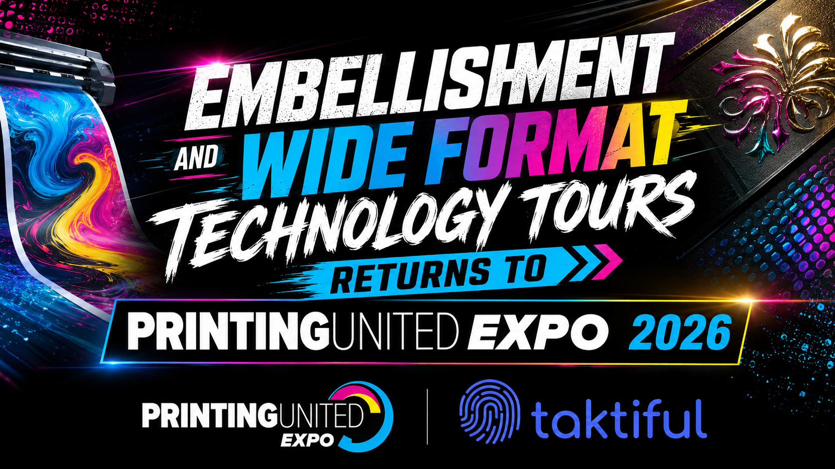
Powered by Taktiful in strategic collaboration with PRINTING United Alliance, the guided walk-and-talk tour pairs engaged attendees with ten leading embellishment brands across two dedicated tracks at PRINTING United Expo 2026.
MELBOURNE, FL – July 22nd, 2026 – Taktiful today announced the return of the Embellishment Technology Tour, the guided show-floor experience produced by Taktiful in strategic collaboration with PRINTING United Alliance, and confirmed that its Digital Production track has officially sold out. The tour, which returns to PRINTING United Expo 2026 at the Las Vegas Convention Center in Las Vegas, NV, gives pre-registered attendees a curated, expert-led path through the most compelling embellishment technology on the show floor.
New this year, the tour has expanded from a single ten-stop experience into two full ten-stop tours running side by side: Digital Production (North Hall) and, for the first time, a standalone Wide Format tour (Central Hall). Rather than folding wide-format sponsors into the original track, Taktiful built Wide Format out as its own dedicated ten-stop experience, complete with its own guides, its own pre-registered attendees, and its own sponsor lineup.
With more than 800 exhibitors expected on the floor this year, navigating PRINTING United Expo for embellishment-specific solutions can be overwhelming even for experienced buyers. The Embellishment Technology Tour was built to solve that problem: small, focused groups of pre-registered attendees are walked directly to a curated set of exhibitor booths by Taktiful's print embellishment experts, who deliver a custom talk track built specifically for each stop.
“The fact that our Digital Production track sold out well ahead of the show tells you everything you need to know about where this industry’s attention is right now,” said Kevin Abergel, Founder and CEO of Taktiful. “Attendees don’t want another lap around the show floor. They want a curated, expert-guided path to the technology that will actually move their business forward, and that’s exactly what this tour delivers.”
“PRINTING United Expo is designed to bring the entire industry together under one roof, and programs like the Embellishment Technology Tour help attendees get more out of that experience,” said Joshua Carruth, EVP, Expositions, PRINTING United Alliance. “We’re glad to collaborate with Taktiful on a program that gives attendees a focused, high-value way to engage with embellishment technology at the Expo.”

Digital Production Track (North Hall): Sold Out
All ten sponsor stops on the Digital Production track are now confirmed. Attendees on this track will be guided through:
- Konica Minolta
- Scodix
- Duplo
- Sharp
- Fujifilm
- Skandacor
- Impress Systems
- Xerox
- Neenah Paper
- Nobelus

Wide Format Track (Central Hall): Open for Sponsorship
New for 2026, Wide Format is now its own dedicated ten-stop tour rather than a secondary track, with up to ten Guided Tour Sponsor positions available. Sponsorship slots on the Wide Format track remain open, with a limited number of Guided Tour Sponsor positions available. Sponsors on this track receive a dedicated stop during all guided tours, a custom-branded tour jersey displayed in the Taktiful booth, inclusion in the official Tour Guide, logo placement on official attendee tour bags, pre-show social coverage, digital wall presence at the Taktiful booth, a complimentary pre-show Taktisphere Live! event, and inclusion in the post-show roundup article distributed across Taktiful's channels.
Each track features five expert-guided tours — two per day, with a final tour on the last day of the show — with 20 to 40 pre-registered attendees per tour. Every stop includes a live demonstration and branded giveaway, and the full experience is professionally photographed and filmed for post-show marketing use by sponsors.

Event Details
Event: Embellishment Technology Tour
Presented by: Taktiful, in strategic collaboration with PRINTING United Alliance
Location: PRINTING United Expo 2026, Las Vegas Convention Center, Las Vegas, NV
Dates: September 23–25, 2026
Digital Production Track (North Hall): Sold out
Wide Format Track (Central Hall): New for 2026, open for sponsorship, limited availability
Secure Wide Format sponsorship: Contact Eric Vessels at eric@taktiful.com or (740) 417-3333.

About Taktiful
Taktiful is the world’s leading digital embellishment consultancy, dedicated to transforming printers, manufacturers, and brands through the unmatched power of #SexyPrint. By combining expert consulting, tailored training, and innovative software development, we empower clients to elevate their embellishment workflows, boost their marketing impact, and increase sales with stunning sensory print. Headquartered in Melbourne, Florida, with a global reach spanning North America, LATAM, and APAC, Taktiful merges deep industry expertise with practical strategies, turning captivating print enhancements into profitable opportunities. Discover how Taktiful makes sensory print seriously successful at www.taktiful.com.

About PRINTING United Alliance
PRINTING United Alliance is the most comprehensive member-based printing and graphic arts association in North America, comprised of the industry’s vast communities. The Alliance serves industry professionals across market segments with preeminent education and training via iLEARNING+, workshops, events, research, government and legislative representation, safety, and environmental sustainability guidance, as well as resources from our leading media brands – Printing Impressions, Packaging Impressions, Wide-format Impressions, In-plant Impressions, Apparelist, and Promo Impressions. The Alliance is also a global leader in standards training and certification for printing and graphic arts operations across the entire industry supply chain.
PRINTING United Alliance also produces PRINTING United Expo, the most influential days in printing. The expansive display of technology and supplies, education, programming, and services are showcased to the industry at large, and represents all market segments in one easily accessed place.
Contact:
Eric Vessels – Chief Experience Officer, Taktiful
📧 eric@taktiful.com | ☎ (740) 417-3333
www.taktiful.com

